Proposed 04 nights/05 days Safari
Day 1: Arrival-Amboseli
Arrive in Nairobi on morning flight, met by our driver who will give you a brief on your safari and depart for Amboseli.
Amboseli is renowned for a beautiful view of Lake Kilimanjaro the biggest mountain in Africa and also large Herds of Elephants.
Arrival in time for lunch. Afternoon game drive with dinner at Oltukai Lodge or Kibo Safari Camp.

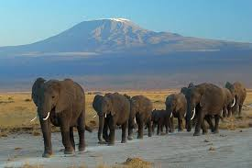

Day 2 : Amboseli -Nakuru
Depart Amboseli for Lake Nakuru arriving in time for lunch.
Afternoon game drive with dinner and Overnight at Lake Nakuru Lodge ( Meals on Full Board)

Day 3: lake Nakuru -Lake Naivasha
Depart Nakuru after breakfast for Lake Naivasha arriving for lunch.
Afternoon spent on leisure or on activities like a boat ride or a visit to the Crescent all at an extra Cost
Dinner an overnight at Lake Naivasha Country Club or Lake Naivasha Resort (Meals on Full Board)

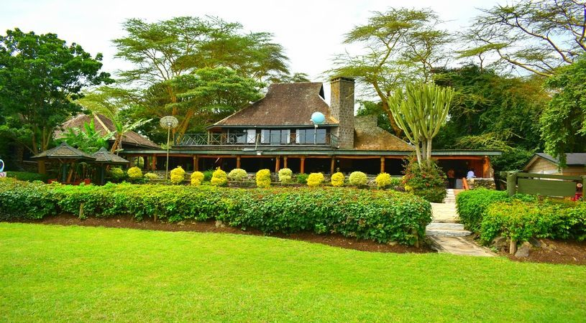

Day 4: Lake Naivasha- Nairobi

After breakfast depart for leave for Nairobi arriving in time for lunch at a city Restaurant
Afternoon visit to Nairobi National Park and if time allows you can have a city Tour.
Dinner at the famous Carnivore Restaurant then transfer to Olesereni Hotel or Four Points for your overnight

Day 5: Nairobi-Departure
After Breakfast you will be transferred to the Airport for your out bound flight.
Transfer to the Airport for your outbound Flight.

Type of a vehicle | p.p.s Based on 06 pax  Oltukai,Naivasha,  Contry club,ole sereni( 4*Hotels & Lodges)  P.p.s based 0n 06 Pax | p.p.s based on 06 pax  Kibo,Naivasha Resort,& Four Points(3*Hotels & Lodges) | p.p.s based 08 pax  Oltukai, Naivasha Country& Olesereni (4* Hotels & Lodges | p.p.s based on 08 pax  Kibo, Naivasha Resort& Four Points( 3* Hotels& Lodges)
4x4 | 1,040 | 980 | $ 995 | $ 930
Minivan | 995 | 930 | $ 970 | $ 880
S.R.S |  |  | $ 330 | $ 280

The above cost includes;
- Return Transport
- Game drives
- PARK Entrance fee
- Two 500 ml bottles per day while on Safari
- Full Board accommodation while on Safari
- Accommodation on Half Board in Nairobi

Above costs are current and subject to change and availability do Not include
- Drinks,
- Telephone calls,
- Tips, international flights and personal gratuities.
- Boat Ride @$ 30 per person
- Crescent Island visit @ Usd 50

