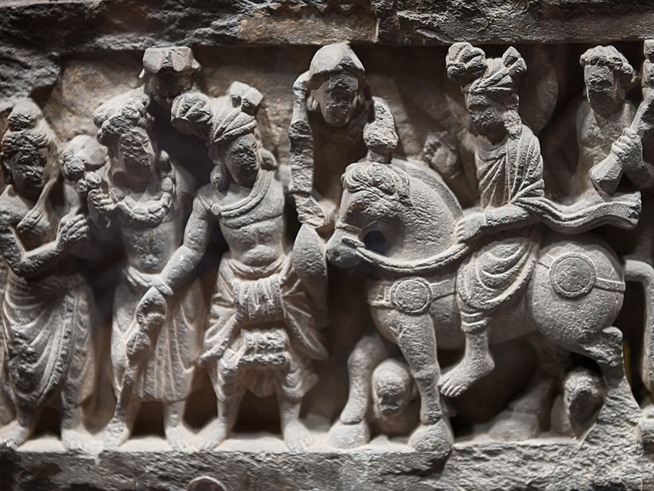

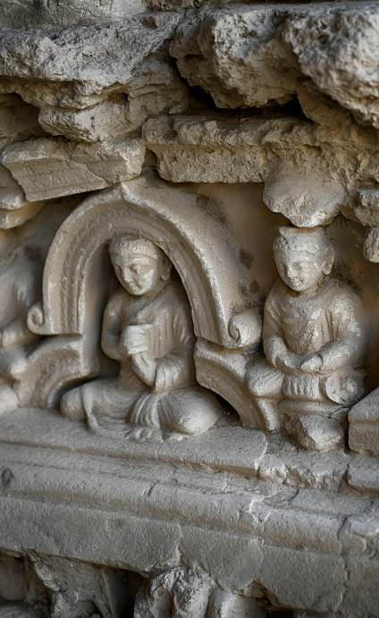
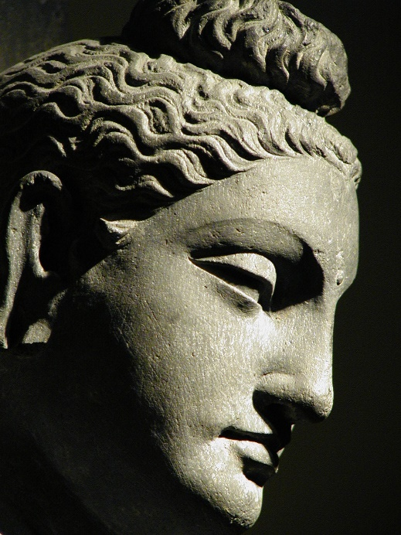

Gandhara & Art of Gandhara

Gandhara was the name of a region located in the present northwestern part of Pakistan. In the north it was extended into Swat valley while the valley of Peshawar was making is southern territories. In the west it included Jalalabad in Afghanistan. River Indus including Taxila marked its eastern boundary line.
Ancient Gandhara is mentioned in Rig Veda 1500-1200 BC when the Aryan migrations happened in the region. It is also mentioned in Avesta as one of the most beautiful land created by Ahura Mazda. It was part of Achaemenian Empire in 5th century BC, Darius the Great mentioned it as a subject nation. During the invasion of Macedonian army led by Alexander the Great in 326BC, asserted their claim over the lost provinces of Achaemenian Empire. Alexander the Great had left a huge territory which was inherited by his generals and one of them being Seleucus Nicator founded his own Seleucid Empire. After the consolidation of power in the western territories, Seleucus Nicator started waging war against the Mauryan emperor Chandragupta who had occupied territories beyond Indus. But continuous failure of Seleucids in stopping the Mauryan forces, made Seleucus Nicator, enter into an agreement with Chandragupta Maurya, with Indus river marking as boundary line between the two empires. Gandhara came under direct rule of the Seleucids in 312 BC – these were the times when Greek art and culture started to take place in the territories and beyond under Seleucids. The later Seleucid King Antiochus Soter 280 BC, founded the city of Ai Khanoum in northern Afghanistan. These along with other cities under the control of Greeks became vibrant in their culture, effecting all the territories in their administration of which Gandhara was an important part. People followed Zoroastrian and Hindu faith along with Greek mythology by people of Greek decent while Buddhism may have reached Gandhara in 3rd BC. After the dismemberment of Seleucid Empire, the Mauryan Empire expanded deeper into the territories held by Seleucids. During the reign of Ashoka the Great who came to Taxila in 230 BC then after attaining kingship and after his conversion to Buddhism he sent monks throughout his kingdom whereas Gandhara is concerned saint Mahyantika, came to reorganize Buddhist monasteries. Also it is said that Ashoka sent Buddha relics to Taxila and as well to Swat. After the death of Ashoka in 232 Mauryan Empire, gradually came to an end and divided among smaller rulers in Gandhara. Around 180BC the colonizing Greeks from Bactria, commonly known as Indo-Bactrian Greeks expanded eastwards, occupied Gandhara and promoted their culture which can be seen in the local sculpture. This turned out to be more of a mixed presentation where the sculptor’s identity is reflected in the work produced. The local sculptors who were involved in the production of theocratic art work reflected their love of faith with the best execution of their master piece produced. Like human anatomy plays a vital role in a Greek or Roman work it also effected Gandharan sculpture which initially copied the Hellenic form then transformed it into more vernacular form. A Buddha image with an Apollonian face wearing Toga is soon to be seen with well-defined moustaches and elaborate jewelry aristocrat men wore in those days. The sandal was typically copied from a Hellenic sculpture. Then flying angels and Greek mythological elements have greatly been reflected with Indian interaction which successfully developed into a more realistic work to be known as the Gandharan Art. We see numerous monasteries throughout Gandhara formed factories producing the great art work which kept maturing with the passage of time. Gandhara Art enjoyed patronage of the state and became an important propaganda tool of the local rulers who sent their masters to various lands. From Northern Pakistan to Afghanistan and into Central Asia, Buddhism flourished and travelled on the Great Silk Road as we can see the effects of Gandharan art as far as Longman Grottoes in China, into Korea and even Japan. Peshawar Valley became the center of Buddhist art where the first anthropomorphic form of Buddha originated and during the reign of Kushan King Kanishka, Peshawar city boasted of having one of the greatest Buddhist Stupa as mentioned by Huen Tsang, the Chinese pilgrim who visited the site in 7th century AD. This was after the onslaught of White Huns with devastating effect of ransacking and burning of monasteries. He mentions presence of hundreds of Buddhist stupas and monasteries through out Gandhara and alone in Uddiyana(Swat Valley) there were more than fourteen hundred of such religious establishments. The grip on Gandharan state had already weakened after the fall of Kushanas and then invasion of White Huns greatly disturbed the local culture. With the rise and fall of Hindu Shahiya dynasty art and culture came to an end after the invading Muslim ruling class of mixed Persian and Turkic race occupied forcibly bringing an end to iconoclastic culture. Ghaznavids were responsible for the end of Hindu Shahi rule in Gandhara which started in 4th AD till 873 AD. Afterwards local Buddhist and Hindu believers could not resist the continuous onslaught of Muslim invaders. The Hindushahi rulers tried their efforts to revive but the onslaught was so intense that in the absence of any help they could not resisti and made their way into Kashmir. Gandhara by then had fallen into various fragmentary rule but finally came under the Muslim invasion by 1011AD.

Itinerary:
Best Time: All the year round
Pax size: 02 – 15 pax

Day 01: Arrive Islamabad – Flt
meeting on arrival at Islamabad International airport – assistance and transfer to your hotel
Later in the day we shall take orientation tour of Islamabad – drive to prospect point of
Shakerparian hills for a bird’s eye view of Islamabad – visit Museum of Folk Heritage, drive past
the diplomatic enclave, Foreign office building, Supreme Court of Pakistan, the Parliament
House, Presidential Palace and Civil Secretariat offices buildings. Then drive to Margalla Road,
make a short visiting stop at Saidpur village – how once villages used to be in Islamabad.
Proceed to visit the beautiful Faisal Mosque with its towering minarets in modern Islamic
Architecture. We shall then drive to the busy markets of the capital

Day 02: Islamabad – Taxila – Peshawar – 165 kms
We shall start off by visiting Taxila, once eastern most extension of Gandhara whereas River
Indus has been always mentioned as its eastern boundary line but in later years Gandhara did
get extended to Taxila. We shall do an extensive visit of Taxila starting with the first city of Bhir
mound 6th – 1st BC, later drive to Dharmarajika Stupa, then drive to the 2nd city site of Sirkap
dating from 1st BC – 2nd AD – we shall visit the town plan and the shrine of Double Headed
Eagle also the related sites. Later continue and visit the site of Jaulian Buddhist monastery
ruins situated on hillside – this is very well preserved site with most parts of votive stupas. We
shall then continue to yet another monastery ruins of Mohra Moradu with well preserved stupa
in a cell. Third city site of Taxila is under a living village however we can still see the wall of the
city created during the Kushan period 2nd AD. Proceed to yet another interesting site of Jandial

Temple 1st BC from Greco-Bactrian period is said to be a Greek temple under debate.
Afternoon we shall dedicate to the visit of Taxila Museum – the building is very well designed
site museum opened in 1918 under auspicious Sir John Marshall. The Museum displays some
very interesting collection with statues in stone and stucco dating from 1st AD to 5th AD. Also
see a large collection of Jewelry, coins and some expensive utensils. There is a large collection
of house hold and toys..
Later we shall continue our drive to Peshawar on Grand Trunk Road till River Indus making a
stop at Akbar’s Fort 1581 situated on the banks of river Indus
On arrival transfer to your hotel

Taxila:
Taxila as was known to ancient world as Takshasila was an important country situated on the
cross roads of old trade routes to western Asia, eastern India and to the north a road leading to
Kashmir. It was part of the Achaemenian Empire from 6th BC to 3rd BC, when Alexander the
Great led his Macedonian army crossing river Indus was received by the king of Taxila Raja
Ambhi or Omphis with a large tribute of horses and elephants submitting to Alexander the
Great in the hope of garnering support for his arch enemy Raja Porus. Alexander the Great
spent some interesting moments in the first city of Taxila and had interaction with local Sadhus
considered to be the people of wisdom. Taxila was then under the control of Mauryas and it si
said that during Ashoka’s rule Taxila was an important western part of his empire. He is said to
have shared Buddha’s relics after he had ordered opening of the eight ancient stupas and
redistributed the same throughout his kingdom. It is believed that Dharmarajika stupa is the
probable site which might have received the holy relics, unfortunately might have lost to
the treasure hunters as when the main stupa was visited it had already had a gash in the top.
Taxila was part of Bactrian Greeks, then Parthians under King Gondophares had peaceful
period and he is said to have a discussion with St. Thomas the apostle and some say the
Parthian king was converted to Christianity. During Kushana period third city was constructed
however the site still remains under a living village. Most of the monastery construction
happened during Kushan period and also numerous stupas were erected. The fall of Kushans
is greatly due to the invasion of Huns in 5th AD, ransacking and destruction of cities and
monasteries. There was a brief period of revival by KIdara Kushans or the little Kushans but
this was a lame effort and Taxila soon submerged into neglect after the invasion of Muslim
rulers.it was lost in history.

Day 03: Peshawar
Full day sightseeing tour of Peshawar – we shall visit Peshawar Museum known for its huge
collection of Gandharan Art well arranged with episode of Buddha’s life in stone sculpture. After
spending a good deal of time at the museum we shall start on the tour of Peshawar city. We
shall visit traditional streets of Peshawar - Qissa Khawani or story tellers street, the coper
street, then walk to spice street, the cloth market, shoe bazaar, fruit and vegetable market is
very interesting and colorful. We shall then proceed to Gold bazaar, the 1630 mosque of
Mohabat Khan for a grand view we shall climb up an old building. Today we shall also visit 19th
century houses of the rich families

Peshawar Museum:
One of the best museum for the collection of Gandharan sculpture – Peshawar Museum is
housed in a building constructed in 1907 as Queen Victoria Memorial Hall and is constructed in
Victorian and local architecture the building was meant for housing antiquities. Some of the
renowned archaeologists were heading this prestigious museum like Sir Aurel Stein,
Hargreaves Dr Spooner and many reputed ones.
Museum is mainly dedicated to Gandharan sculpture mostly in grey, blue and green schist
commonly seen in stone sculpture of Gandhara. Of recent another large collection has been
added to the museum which has made it into an important museum of the region. Among the
rich collection are friezes depicting the life story of Buddha and later of various episodes of his
life in stone making it as one of the largest animated gallery in stone. Of the prized collections
the best is the King Kanishka’s reliquary casket in bronze was once containing bone ashes of
Buddha. These ashes were presented as humble gift from Gandhara for the people of Burma
during the days of war with Japan. The two seals are still there in the casket which once was
housed in a large Stupa constructed by King Kanishka in the outskirts of Peshawar. This stupa
has been mentioned by Huen Tsang in 7th century while on pilgrimage tour however that was
the decadent period of Gandhara.

Peshawar:
One of the oldest living cities of Pakistan, Peshawar was once a popular caravan town and had
a population comprising Central Asians, Persians and Kurds whose descendants still live in the
old parts of the city though majority of them have moved out to modern locations elsewhere in
the country.
Peshawar though has changed a lot and its old buildings are being replaced by modern
structures but still the local administration is trying its best to maintain its rich heritage. One of
the main purposes of Ahu Travel is to explore and promote old heritage sites and bring to light
an urgent need for conservation of old buildings. Peshawar city character was its bazaars and
Qissa Khawani “the story tellers street”where the caravaneers would come out in the evening
visiting some of the traditional ‘bala khanas’ or the high houses where professional entertainers
performed songs with traditional music. They also acted as providers of the latest travel
conditions and information for their guests. These houses are now in dilapidated condition and
need urgent care and restoration to keep the heritage alive.

Day 04: Peshawar – Khyber Pass – Peshawar
Today we shall take an excursion to Khyber Pass – we shall make few stops at important sites
We shall be proceeding to the last point of Torkham view point
On return we shall try to visit Khyber Rifles Mess (subject to permission)
Afternoon free at leisure

Khyber Pass:
The historic gateway to Indian subcontinent, Khyber Pass was the thoroughfare for migrations
and invasions. These migrations like some of the Aryan tribes might have passed through this
passage as early as 1400 BC then ruling or invading armies of Persians, a section of
Macedonian army also used this passage. When the caravan movements started this became
a popular way as it was the shortest and easier way of travel. The Afghan ruling forces, Turkish
armies, the Mongols, then their ancestors, Tamerlane‘s armies and later his descendants the
Great Mughals used this pass strengthening and regulating the passage we can still see part of
this road constructed by Akbar the Great in 16th century. After the fall of Mughals, Sikh armies
used the passage for control of raiding tribes from Kabul. Later when the British completed their
control of India in 1890s they were always worried about protection of their richest colony of
India from the west. In 1880s they had grown a phobia of invasion by the Czarist forces. The
Russians were busy controlling Turkestan which had small stately ruling classes called
Khanates. By negotiations and fighting off rebellion they were able to maintain some control
under local autonomy. On the other hand British had started working on complete control of
their western borders where the had to fight three Afghan Wars.
Khyber Pass remains as the bastion of security for Pakistan and a potential trade route from
the west to east.
Talking of Buddhist periods, Khyber Pass was an important route for going to Afghanistan and
there are several places in the pass testifying its importance. The signs of several stupas could
be seen until recently but most of these structures were destroyed by the iconoclastic folks.
Though the beautiful Ali Masjid stupa is no more but couple of them like Sphola and the other
close to Ali Masjid passage perched on a hill is still there. All these places were robbed of their
interned caskets or other objects.

The long trains of caravans are gone but their routes still stand witness to great trading and
migratory activity once this place had seen in the past is now part of our history.

Day 05: Peshawar – Charsadda – Takht-i-Bhai – Saidu Sharif – 170 kms
This morning we shall be driving upto the Swat valley – enroute we shall make our first stop at
Charsadda to visit Hissar ruins. Later our next stop will be an interesting visit of well preserved
Buddhist monastery of Takht-i-Bhai perched on a hilly spur. Continue to Saidu Sahrif via
Malakand Pass

Pushklavati Site:
The City of Lotus was famous for its lotus trade mark – lotus grows a lot still in the standing
pools of Swat river, once flowed through the capital city of Gandhara. The site popularly known
as Hissar owing to high walls of a fairly large city dates from 6th BC or even earlier. Pushklavati
was besieged by Alexander the Great in 325 BC for quite sometime before crossing a bridge
over the of flowing Swat river formed a defensive moat around the city. Alexander’s army could
only do it through the help of an old man – the bridge site was excavated with marks of pot
holes holding timber. We shall have short walk to higher parts of the city spread over with pot
shreds a lucky one should look for a pot shred with lotus mark!

Takht-i-Bhai Buddhist Monastery:
Perched on a hilly spur, Takht-i-Bhai was a large complex of secular buildings and from the
structure it looks was a strong Buddhist monastic establishment and laid out in a disciplined
manner. A rock inscription in Khoroshti was found with depicting the ruling period of King
Gondophares as 45AD. The large number of sculpture found from the monastery shows it was
an establishment of high order with state patronage. Students who came from various countries
or regions left their marks by contributing a series of votive stupas. Thanks to its high situation it
must have been spared by the invasions. The surrounding countryside marks a popular
presence of many Buddhist sites – one of them being Jamalgarhi where the first
anthropomorphic form of Buddha was carved.

Day 06: Saidu Sharif
We shall spend the first half of the day visiting Swat Museum, sites of Butkara and Udegram
city sites. Swat sites were excavated by the Italian mission in detail unearthing some wonderful
monastery sites. In the second half we shall make visit of Upper Swat valley – we a short visit
of rock carved image of Buddha at Jahanabad

Swat Museum & sites:amous Chinese pildg
Uddiyana of the Buddhists Swat valley played a vital role in the spread of Buddhism. After the
defeat of Assakinoi the local population of Swat at the hands of Alexander the Great, we hear
about the valley described by the famous Chinese pilgrim Huen Tsang who visited the places in
7th AD when the valley was already devastated by the Hun invasion burning the Buddhist
buildings and killing the local population. He cuts a sorry picture of once great place of learning

was now a place where hardly any Buddhist monk knew the true meaning of Buddhist cannons.
Soon after Swat was swayed by the invasion neo Islamists, the Afghans. Huen Tsang mentions
of the presence of more than 1400 Buddhist monasteries and stupas. Swat is also described as
the possible place of birth of Padmasambhava or Tibetan Lama Rinpoche. The valley also
excels in its scenic beauty as the ancient name Uddiyana means place of fair dwellings.

Day 07: Saidu Sharif – Shahbazgarhi – Islamabad – 255 kms
Morning depart for Islamabad via Karora pass opening up to plain land once center of
Buddhism. Many place below are marked with ruins of monastic establishments. We shall make
our stop at Shahbazgarchi to see rock edicts of Ashoka the Great. Later continue through the
plains following Kabul river and further river Indus – this part also was the crossing point of
Alexander the Great on his march to Taxila. Also there a village called little Lahur was the home
village of 4th century BC, Sanskrit Grammarian Panini.
Continue to Islamabad
Shahbazgarhi Edicts of Ashoka the Great:
Ashoka the Great after his possible conversion to Buddhism ordered opening of the ancient
stupas interned with relics of Lord Buddha – these relics were redistributed throughout his
kingdom and Gandhara being the western most part, must have received its share. The rock
inscriptions or edicts of Ashoka was part of his broad based message for the spread of peace
and fraternity. He had set rules and regulations for the betterment of humanity which is seen as
a remarkable act of Ashokan rule. The edicts of Shahbazgarhi is part of many such edicts
spread around but these are well preserved and fairly visible date from 2nd BC. These are set of
rules depicted of then local script of Kharoshti while the spoken language was Prakrit a middle
Indo-Aryan language

Day 08: Islamabad
Today we shall spend touring Islamabad city and its environs with ample time to explore the
place at your own

Day 09: Depart

